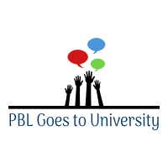
National Curriculum subject content

Year 7 MFL (Spanish) Curriculum: Developing linguistic competence, cultural appreciation and knowledge, and vocabulary
Digital Mentoring Churchill Community College, Wallsend

Project Summary

This exciting project was collaboratively planned and delivered by the Language Resource Centre (LRC) at Newcastle University and the North East Local Enterprise Partnership (NE LEP). The aim was to introduce the students to their Key Stage 3 Spanish curriculum using culture and authentic situations, people and places. The project started with a visit to Newcastle University where pupils took part in a Linguacuisine activity, cooking a Spanish recipe. They spent time in the LRC, met their Language Ambassador and had a Portuguese taster lesson. They then took part in a series of virtual lessons via Skype with the Language Ambassador on a variety of topics including typical food, cultural celebrations and music. The project culminated in a showcase from the partners and an interactive presentation of the students work.

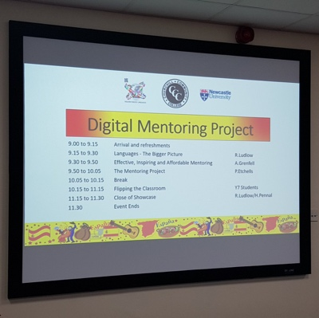
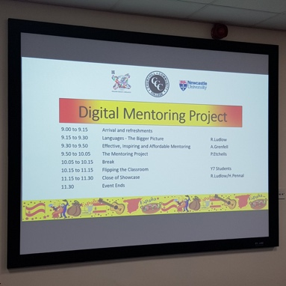
Skill development

- Developing vocabulary, grammar and cultural knowledge
- Using ICT (Skype, iPads)
- Working independently and in a group
- Creating a final product (interactive presentation)
- Communicating ideas, cultural knowledge and vocabulary to an external audience (in lessons to the Language Ambassador and during the final presentation to an external audience)
Cultural capital

The project launch event involved a morning visit to Newcastle University for the whole class. They took part in the Linguacuisine activity in the iLab digital kitchen and had a tour of the LRC and a taster lesson of Portuguese.
They also met Phil, their Language Ambassador, who is an undergraduate student studying Spanish and German at Newcastle University. During the project sessions, two further MFL undergraduates joined Phil to talk about their year abroad in Barcelona, Rio and Lisbon, and how they use languages in their studies and their work. This introduced the school students to the potential of studying MFL at university.
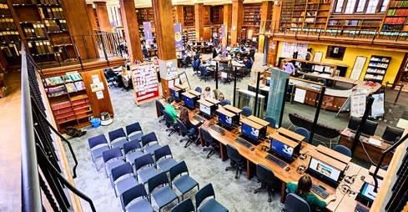
Gatsby Benchmarks

BM4. Linking curriculum learning to careers​ BM 5: Encounters with employers and employees​ BM 6: Experience of workplaces​ BM7: Encounters with further and higher education​

Week 1 | Week 2 | Week 3 | Week 4 | Week 5 | Week 6 | Week 7
Students visit Newcastle University to take part in Linguacuisine and have a Portuguese taster session. Supported by University undergraduate students and Linguacuisine team | Students take part in session 1 of the digital mentoring programme.  Delivered by University Language Ambassador | Students take part in session 2 of the digital mentoring programme.  Delivered by University Language Ambassador | Students take part in session 3 of the digital mentoring programme.  Delivered by University Language Ambassador | Students take part in session 4 of the digital mentoring programme.  Delivered by University Language Ambassadors | Students take part in session 5 of the digital mentoring programme.  Delivered by University Language Ambassadors | Showcase: Students present on one of the weekly topics.  External audience: ambassador,  LRC staff, university researcher, NE LEP
“I enjoyed learning the song and doing the presentation” (Student)

“I learned so much about the traditions, culture etc to do with Spain and I think that is really helpful” (Student)

“I enjoyed being able to go beyond the classroom and broaden my knowledge” (Student)

“Learning a language alongside the culture brings an understanding of the culture” (Grandparent)

“They were so engaged and enthusiastic every week” (Ambassador)

“It’s about maintaining motivation and a willingness to speak… I think it’s brilliant that people want to come along and help us, and I’m so proud of our young people” (Headteacher)

Launch event/ Final product and showcase

The project launched with a visit to the LRC. This introduced them to a university environment and showed them how MFL is taught at university. They also took part in a Linguacuisine session where they used a free app to learn Spanish whilst cooking an authentic recipe.
The aim of the project was to introduce the students to Spanish culture in a context outside a typical classroom. The Language Ambassador used authentic images, songs and real life cultural celebrations to teach the related vocabulary and get the students talking to one another in the target language.
The showcase event invited external partners, parents and grandparents to the school where the Language Ambassador and Head of MFL discussed the importance of languages in the world of work. Students then presented their work with audience interaction.
Project activity and timescale

Project feedback

Learning for next time

Richard Ludlow, Churchill College Curriculum Leader for Modern Foreign Languages, said:
“As a pilot project I felt that the overall delivery, organisation and final presentation were a real strength and a resounding success. All stakeholders including colleagues from Churchill, Newcastle University and the LEP enjoyed the final showcase and I know the students really enjoyed being involved in the project and they have rejoined their lessons with a real thirst for language learning. In terms of moving forward there were a few logistical and technical areas which could be improved which include the organisation of staffing here at Churchill but also ensuring that the equipment is appropriate for voice communication as I know sessions were sometimes disturbed by the internet connection. Secondly, from an academic perspective, it would be interesting to try and align learning in the classroom more closely with the project so that the two things aren't running separately but instead complement each other more deliberately.”
Student feedback:
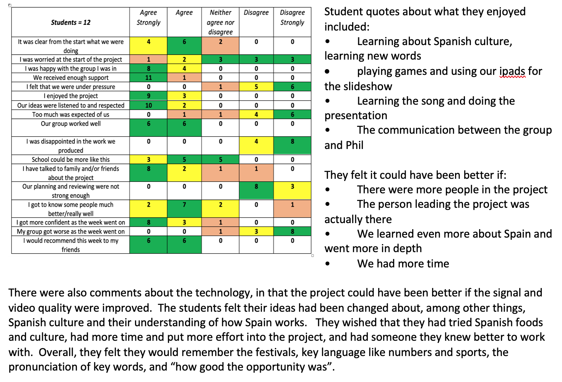
Useful links/resources/ideas

Newcastle University Language Resource Centre: https://www.ncl.ac.uk/language-resource-centre/
Linguacuisine, Newcastle University: https://linguacuisine.com
If your school isn’t near Newcastle, find your local university/college outreach teams.
Resources relating to this specific project on our website.
General resources on our website: blank planning tools, links to useful websites, more case studies

